Creating a Child Repository (Microservice Setup)
Objective
The objective of this step is to create a child microservice repository that follows the standard One App microservice architecture and is linked to an existing parent repository. This ensures modular development, independent deployment, and clear separation of responsibilities while still allowing integration with the parent application.
Background
The structure followed for the reporting-manager service is based on a microservice approach. In this approach:
A child component (module) is created as a separate repository.
The child component is linked to the parent/root module using configuration defined in package.json.
This linkage allows the parent application to consume the child module seamlessly.

Steps to Create the Child Repository
1. Select the Target Directory
Choose the folder location on your local system where the child module repository should be created.
This helps in maintaining a clean workspace and proper separation between multiple projects.
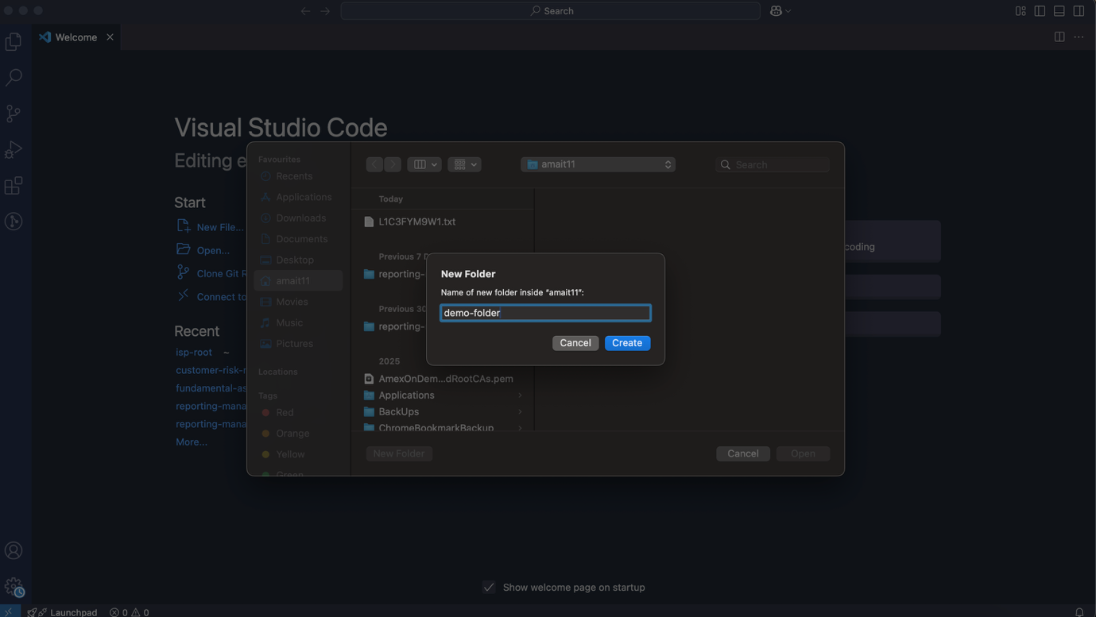

2. Initialize the Child Module Using Template
Run the following command to initialize the project using the standard One App module template:
npm init using-template @americanexpress/amex-one-app-module-template@latest
This command scaffolds the project with predefined configurations, dependencies, and best practices required for a One App child module.
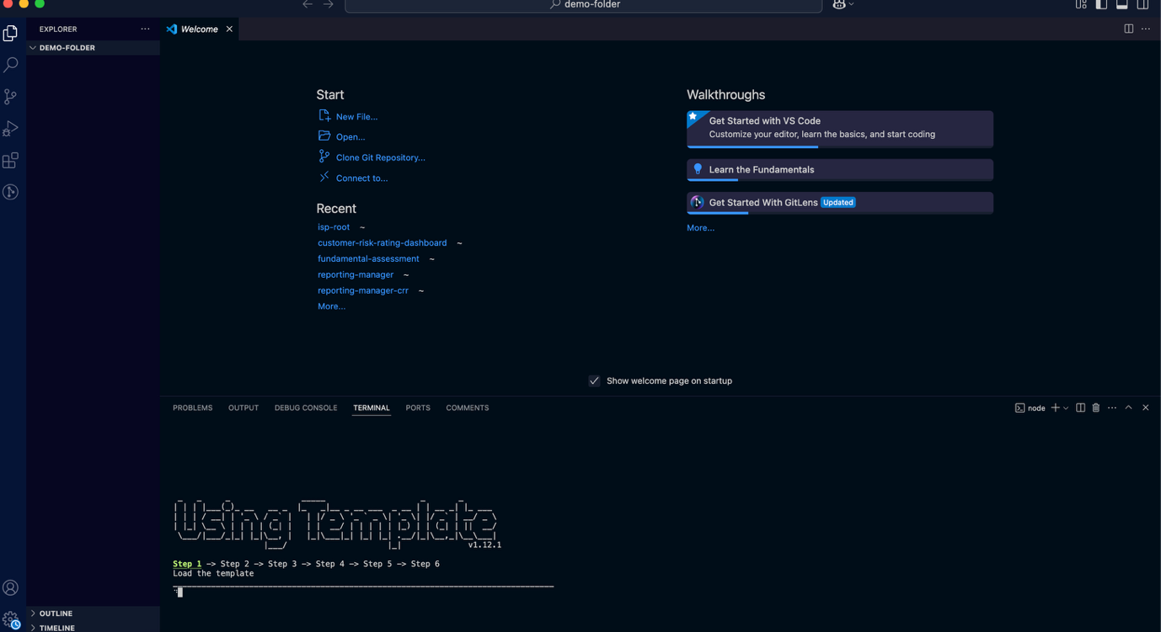

3. Provide Project Configuration Details
During initialization, you will be prompted with a series of questions related to the project configuration. These include:
Project name
Version
Whether the module is a child or parent module
Other module-specific metadata
These details define the identity and behaviour of the microservice.
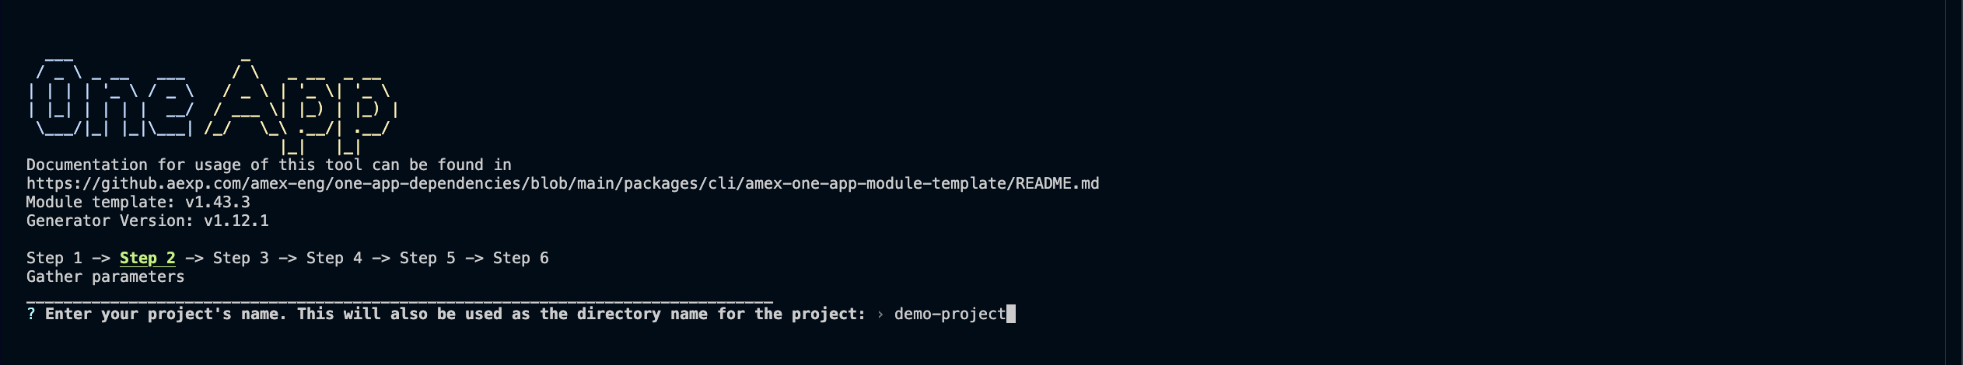
4. Specify the Root (Parent) Module
When prompted for the root module name, enter the name of the parent repository you want this child module to be linked to.
For example:
If the parent repository is customer-risk-rating-dashboard, enter this exact name.
This step establishes the linkage between parent and child repositories via package.json.
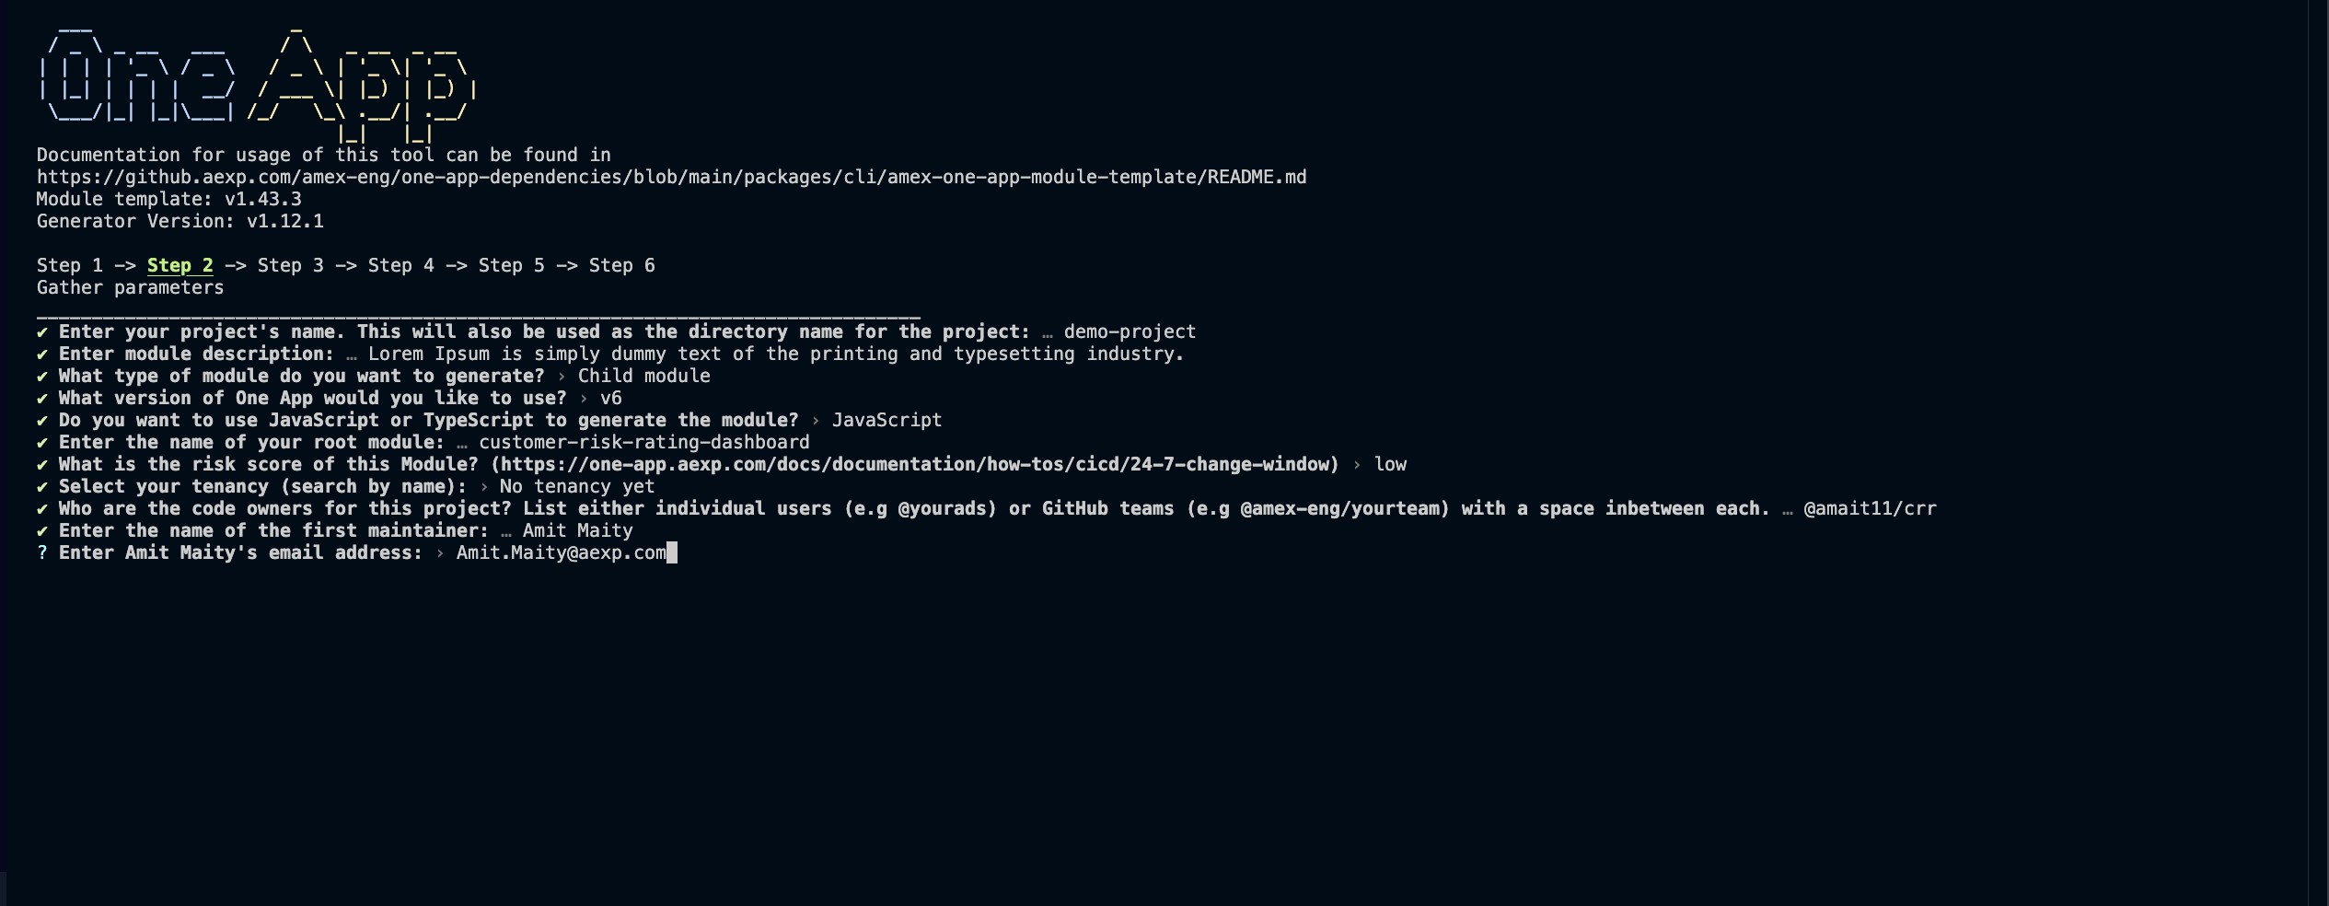
5. Enter Ownership and Contact Information
Provide the required ownership details, including:
Code owner name(s)
Associated email address(es)
Above given picture gives an idea for the same. This information is important for governance, ownership clarity, and future maintenance.

6. Provide Central ID for the Project
Enter the Central ID assigned to the project when prompted.
This ID is used for internal tracking, access control, and organizational alignment.
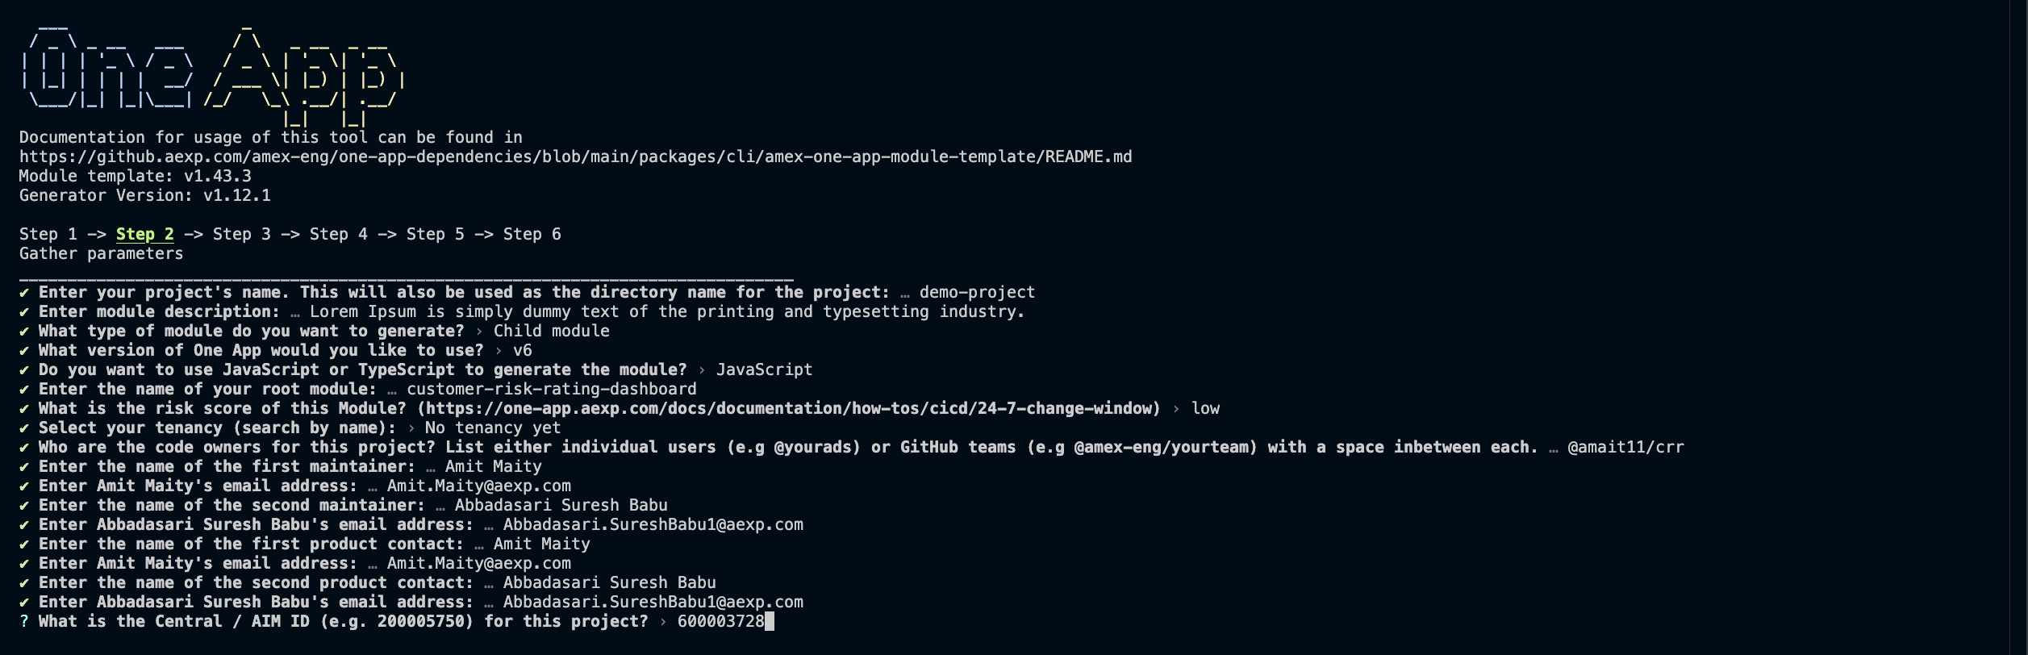
7. Package Installation and Project Setup
Once all required details are entered:
The system automatically installs the necessary packages.
The child module repository is fully initialized and ready for development.
At this point, the project structure is successfully created and linked to the parent module.

Reference Documentation
For additional details or troubleshooting related to child module creation, refer to the official documentation:
https://one-app.aexp.com/docs/documentation/getting-started/creating-a-child-module

Creating a New Repository in GitHub
Objective
This step ensures that a centralized GitHub repository is created for the child microservice so that code can be version-controlled, shared, and integrated with enterprise tooling and pipelines.

Steps to Create a Repository in GitHub
1. Navigate to the GitHub Organization
Visit the amex/eng organization on GitHub and click on the New button to create a repository.
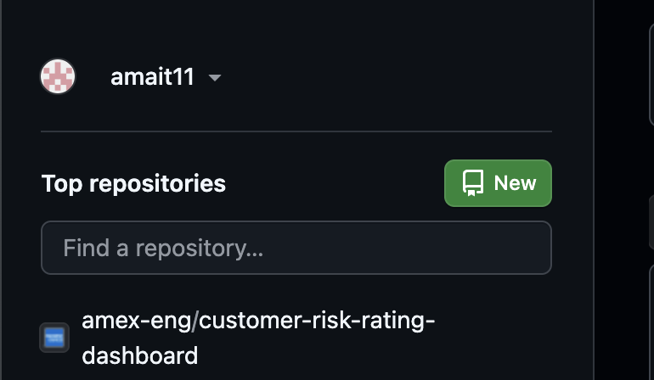
2. Enter Repository Details
Provide the following details:
Repository name
Short project description
These details uniquely identify the microservice and help with discoverability.
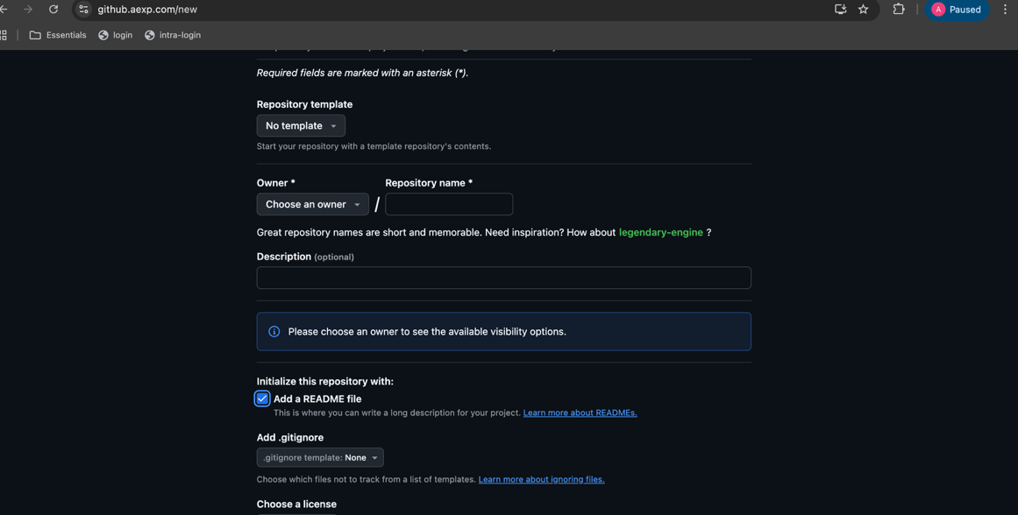

3. Set Repository Visibility
Ensure that the repository visibility is set to Internal and not Private.
This allows access within the organization while maintaining security standards.
Select the README checkbox during 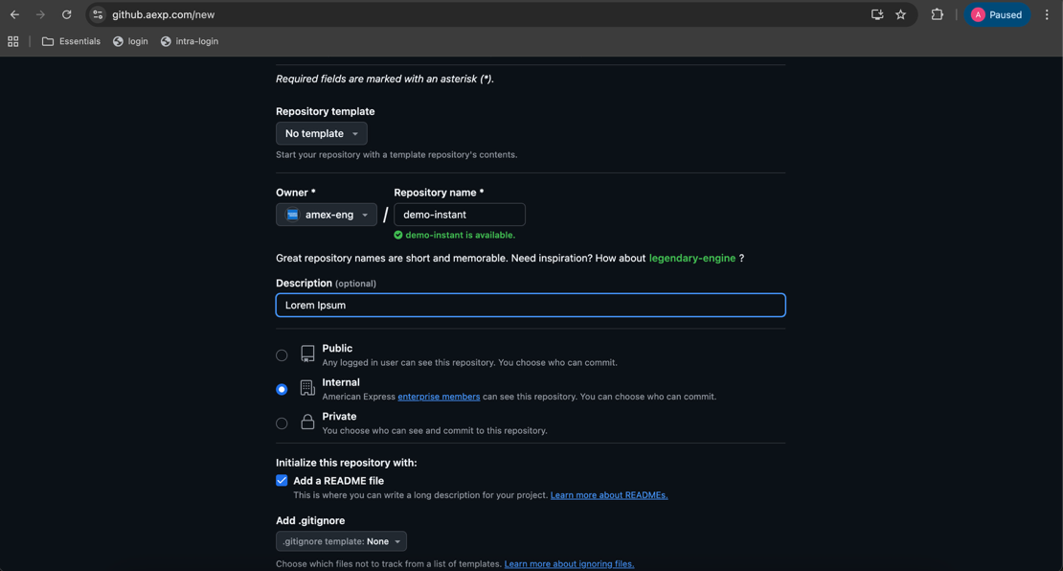creation.
This initializes the repository with an empty README file, which is required for the initial setup and documentation.

4. Clone the Repository
Once the repository is created:
Clone it to your local system using SSH or HTTP, depending on your system’s authentication setup. (git clone <copied-url>)
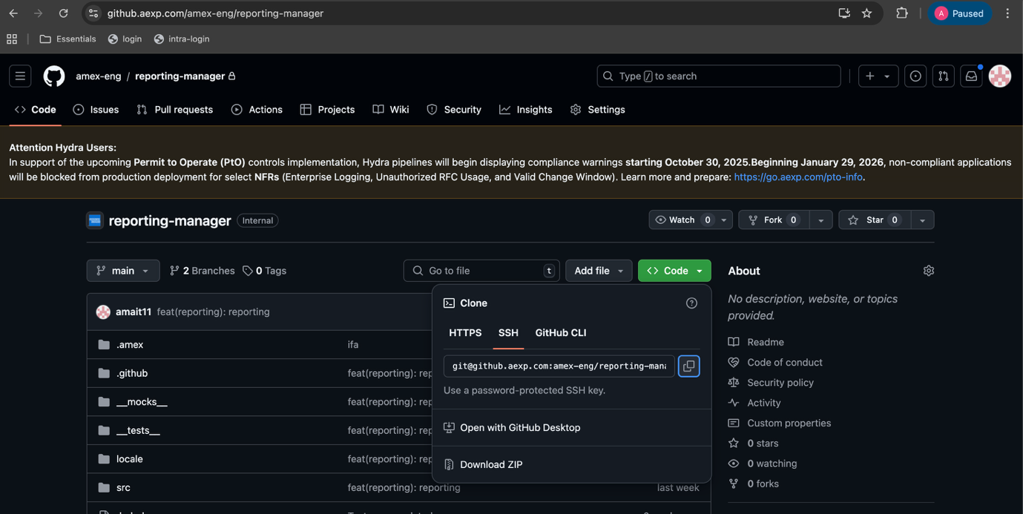

Step 3: Initial Setup and Validation of the Repository
Objective
To verify that the repository is correctly set up and that all dependencies are installed before linking it to other components.

Steps
1. Install Dependencies
Run the following command once after cloning the repository:
npm install
This ensures that all required dependencies are installed and the project is in a runnable state.
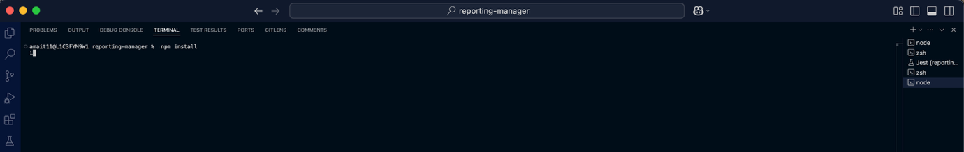

2. Validate Local Changes
Test all changes locally to confirm that the setup is functioning as expected before committing any code.
Step 4: Maintaining the Repository and Central ID Validation
Objective
This step ensures that the repository meets code quality standards, is properly tracked under the Central ID, and is eligible for enterprise-level reporting.

Steps
1. Commit Latest Changes
Commit all recent changes to the GitHub repository with appropriate commit messages.
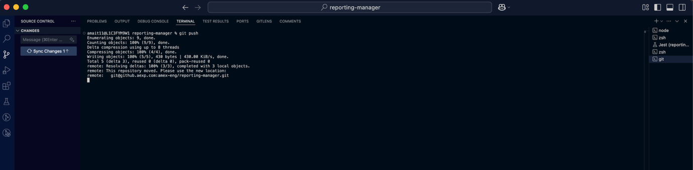

2. Ensure Test Coverage
Write and execute all required test cases, ensuring:
Test coverage meets or exceeds the 80% threshold
This guarantees code quality and long-term maintainability.

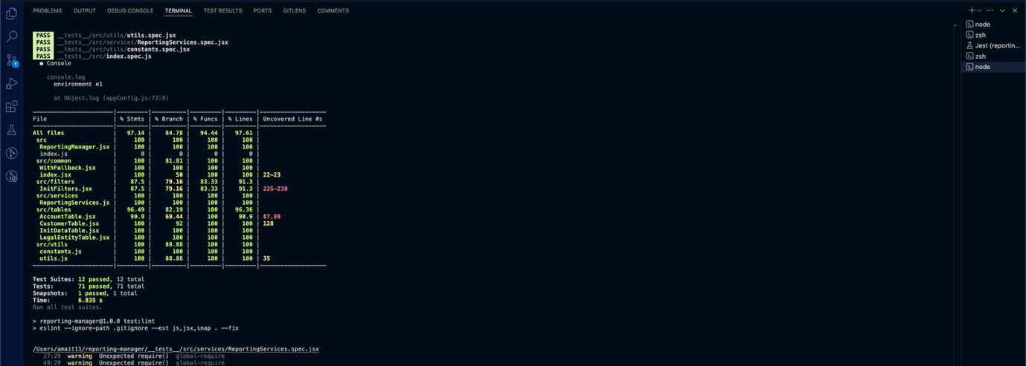
3. Push Changes to Main Branch
Once validation is complete, push all changes to the main branch.

4. Verify Central ID Configuration
Ensure that the .amex folder exists in the repository and contains a buildblocks.yml file.
This file must include the Central ID, which allows the repository to be registered under the organization’s central repository list.
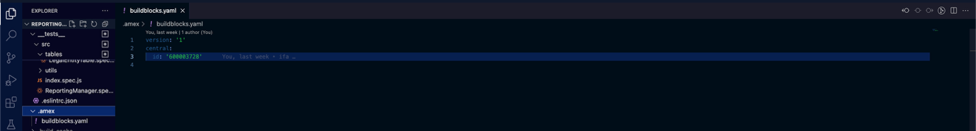

Step 5: Linking the Child Repository to the Root (Parent) Module
Objective
To integrate the child microservice with the parent application so that it can be built, deployed, and rendered as part of the overall system.

Steps
1. Update Root Module Configuration
Open the root module repository.
Open its package.json file.

2. Extract Child Module Name
Open the package.json file of the child module.
Copy the value of the "name" property.

3. Register Child Module in Root Module
Paste the copied child module name under the modules section in the root module’s package.json.
This establishes the parent–child relationship.
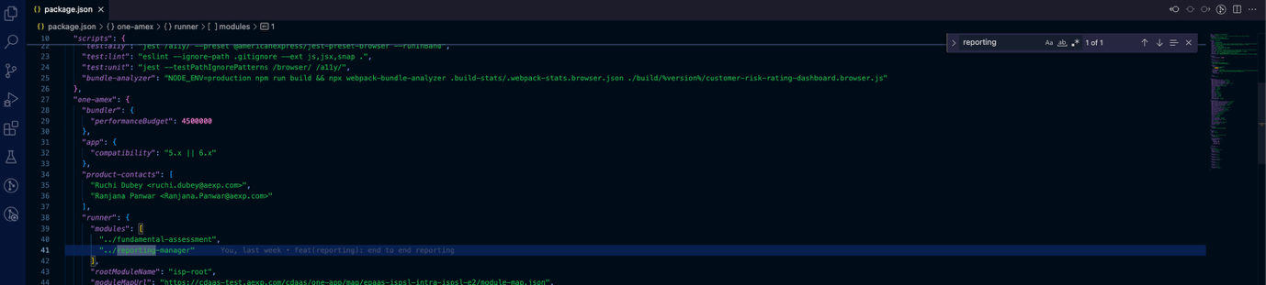

4. Clone Additional Required Repositories
Clone and install the following repositories, similar to the parent module setup:
isp-root
isp-portal

5. Update isp-root Configuration
In the isp-root repository:
Update the module name in:
- package.json
- childRoutes configuration file
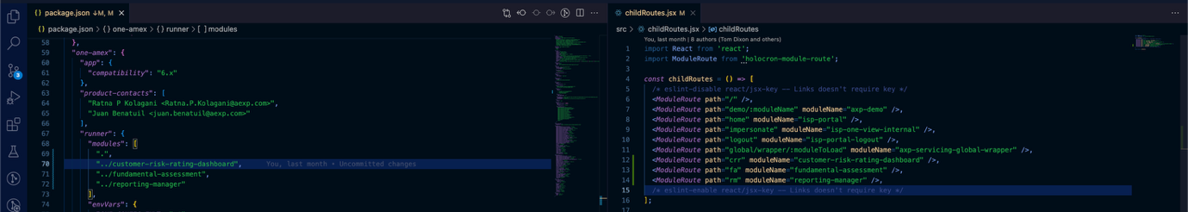
6. Update isp-portal Configuration
In the isp-portal repository:
Open package.json
Add the child module name under the modules section, similar to the isp-root configuration.
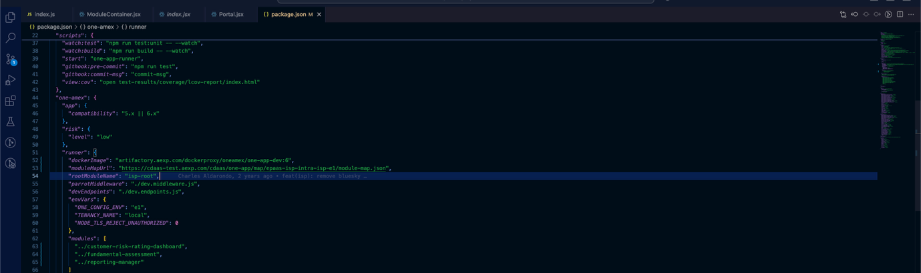
Step 6: Verifying Build and Application Health
Objective
To confirm that all repositories build successfully and the application is running correctly in the local environment.

Steps
1. Run Build Commands
Execute the following commands on all repositories:
npm run build
or
npm run live:build

Ensure all builds complete successfully.

2. Start Application via isp-root
Run the following command in the isp-root repository:
npm run start
Open the Docker application when prompted.
Verify Docker is running and healthy (green status).
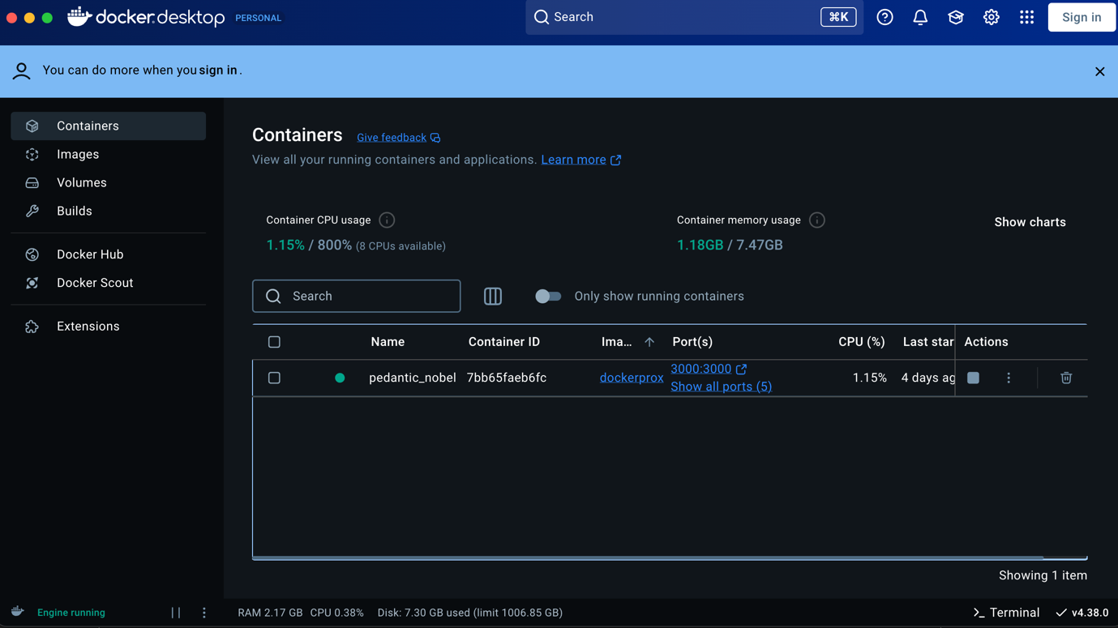

Rendering the Child Microservice Inside the Parent Module
Objective
To render the child microservice within the parent application using the Amex Holocron framework.

Steps
1. Identify Target Parent Component
Open the parent component where the child microservice needs to be rendered.

2. Load Child Module Data
Use the provided Amex library function to load module data inside your component:
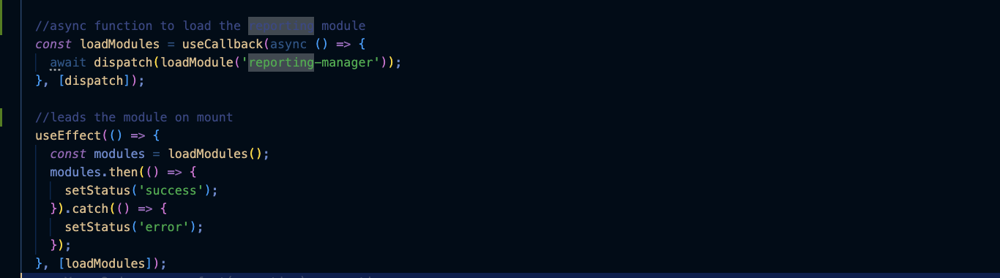

3. Render the Child Module
Use the <RenderModule /> component provided by holocron to render the child microservice.
It accepts the following props:
moduleName: Name of the child module
props: Additional properties used for communication between parent and child microservices
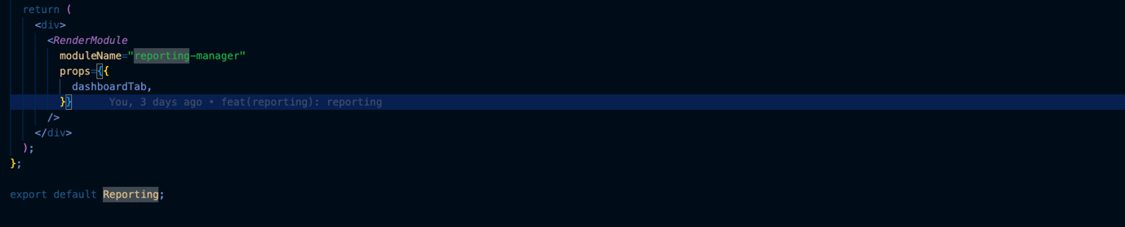

Final Validation
Once all steps are completed successfully:
Navigating to the relevant parent component will display the child microservice correctly.
This confirms that repository creation, linking, build, and rendering have been completed successfully.
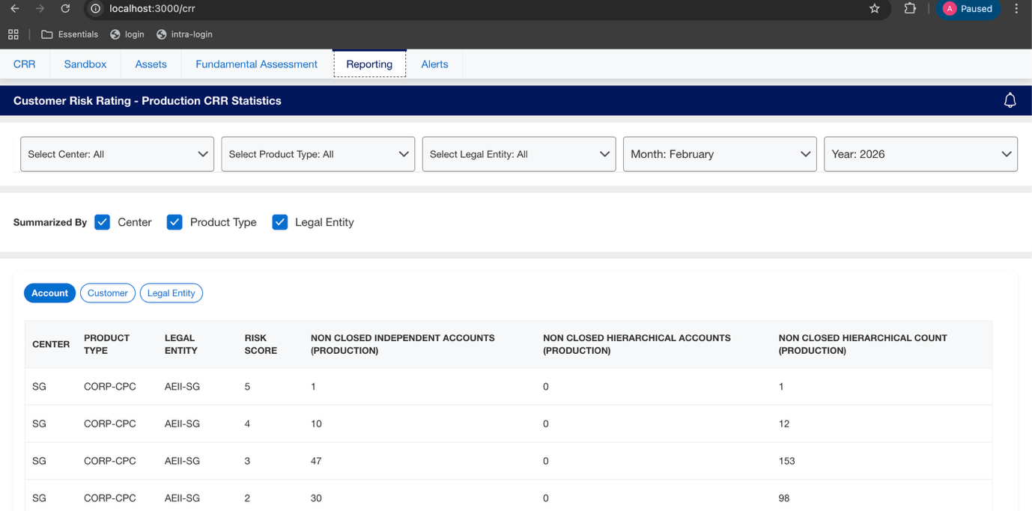
Happy Coding!

